

| Classification Proposal | |
| --- | --- |
| Control Report (RC) | |
| **Date** | 16/11/2024 |
| **Academic year** | 2024/2025 |
| **Lecturer** | João Varajão |
| **Degree** | Master's in Telecommunications and Computer Engineering (METI) |
| **Year** | 2nd Year |
| **Curricular Unit** | Gestão de Projetos de Tecnologias de Informação (GPTI) |

The Team 03

The team is made up of four members, three of whom are 2nd year students on the Master's in Telecommunications and Computer Engineering and are identified by PG (Postgraduate) followed by their mechanography numbers, while the fourth member is an Erasmus student on the same degree and is identified by the code E (Erasmus) followed by his mechanography number.

**Catarina da Cunha Malheiro da Silva Pereira**

PG53733

[pg53733@alunos.uminho.pt](mailto:pg53733@alunos.uminho.pt)

Braga, Portugal

**Inês Cabral Neves**

PG53864

[pg53864@alunos.uminho.pt](mailto:pg53864@alunos.uminho.pt)

Porto, Portugal

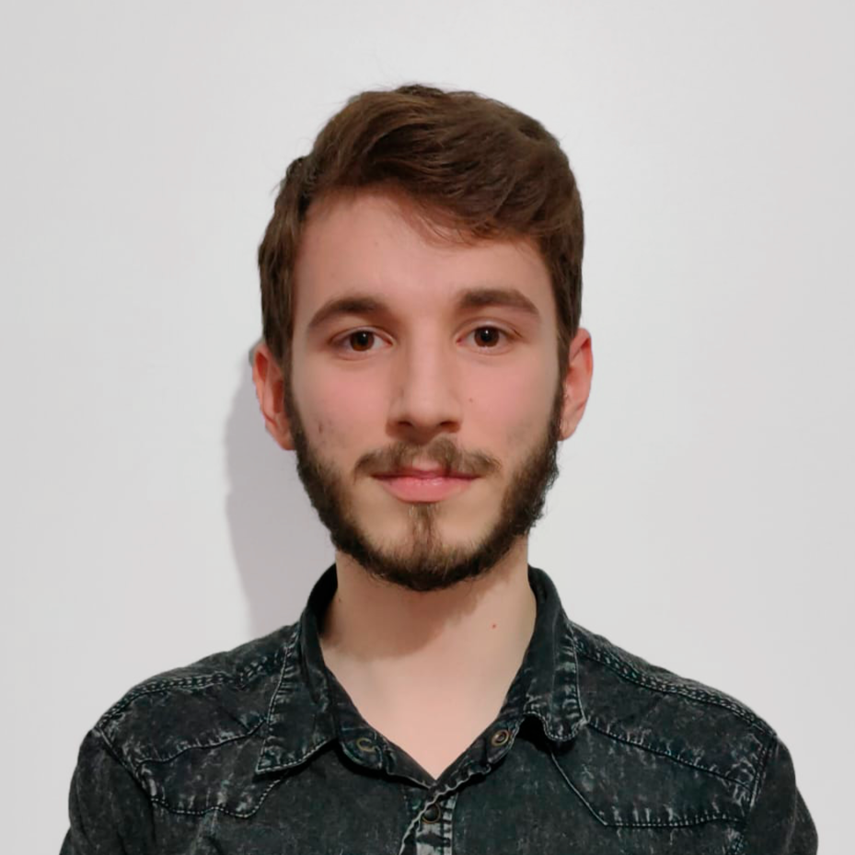

**Leonardo Dias Martins**

PG53996

[pg53996@alunos.uminho.pt](mailto:pg53996@alunos.uminho.pt)

Aveiro, Portugal

**Rodrigo Rocha del Castillo**

E12165

[e12165@alunos.uminho.pt](mailto:e12165@alunos.uminho.pt)

Santander, Spain

Methodology for the Final Ranking

Each group member's final rating will be determined on the basis of a set of criteria that reflect both individual performance and collective contribution throughout the project. Each project deliverable, such as the Project Plan, the first poster and the presentations, is assessed separately, and attendance at meetings also plays a key role in the assessment, as is demonstrated on the Table below.

| **Team Member** | **Clarity and Organisation of Information** | **Visual Quality and Aesthetic Design** | **Work Review and Information** | **Team Meetings** | **Final Grade** |
| --- | --- | --- | --- | --- | --- |
| Catarina Pereira | 19 | 17 | 17 | 20 | 17,7 |
| Inês Neves | 19 | 17 | 17 | 20 | 17,7 |
| Leonardo Martins | 18 | 17 | 17 | 20 | 17,5 |
| Rodrigo Rocha | 17 | 16 | 17 | 20 | 17,1 |

The final classification is obtained from a weighted average of each member's contributions to the different parts of the project. In this case, the adjusted weight of the different deliveries and participation in meetings was balanced as follows:

* Clarity and Organisation of Information: 35%;
* Visual Quality and Aesthetic Design: 20%;
* Work Review and Information: 35%;
* Team Meetings Participation: 10%.